Heller Programme, Utilisation of Renewable Energy Sources with Heat Pumps

Ferenc Komlós
Certified Mechanical Engineer, Building Engineer
H-2330 Dunaharaszti, Klapka György u. 41/1. komlosf@pr.hu

Summary

It is inevitable to reduce the amount of energy used in buildings to improve the energy balance of Hungary and to reduce air pollution of towns (settlements). Heat pumps are world-wide known as a heating-cooling technology being most effective in energetic point of view, thus they compose a key element of energy efficiency and of CO₂ emission reduction. Related to the technology of today - and of tomorrow - it is important to mention as well, that not only the heat source but also running of the heat pump and the input energy can originate from non-fossil sources. Potentialities of our country, namely its solar and soil heat energy reserves and its biomass energy potentials in a wide sense and its high level intellectual capital are favourable to the popularisation of heat pump technology utilising renewable energies.

1. Introduction¹
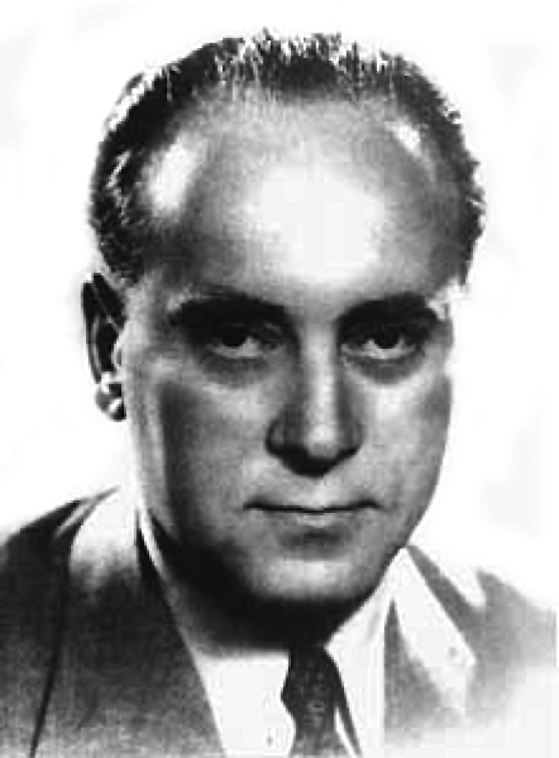

Dr. László Heller (1907-1980) eponym of the programme proposal for the popularisation of heat pump technology was a professor at the Technical University of Budapest and an academic. He defended his doctoral dissertation about the technical and economical conditions of utilising heat pumps in 1948 at the Zurich University. This year we celebrate the 100th anniversary of his birth. In case of accepting it the programme² described here could be launched joined to the anniversary. Heating our Parliament and the Technical University with the second greatest river of Europe was one of the ideas of Heller, the school creating Professor dealing with heat energetics. With the world-wide spread of heat pump systems his ideas are justified now.
The objective of building construction is to ensure an environment being comfortable enough (ventilated, heated or cooled) for the everyday life of people. In excess to this it is the interest of every consumer and user to achieve a rational and efficient energy utilisation.³
Beyond the technical possibilities of reducing the heating energy need, it is hard to determine the money equivalent of the benefits achieved by reducing air pollution of our towns. Related to this issue utilisation of heat pumps has come into the focus. Since the majority of possible purchasers evaluate heat pumps in economic point of view, cost efficiency and refund of investment costs have to be proved as well beyond their comfort in use and environmental benefits.
Taking into account the inevitably existing heat need of heating, cooling, ventilating of buildings adding up a significant amount, our Earth and our country as a part of it are threatened by the increasingly deteriorated air quality, by the impacts of climate change causing huge damages, by the increasing number or environment catastrophes, thus a jurisdictional support of the Heller Programme would be exemplary in international level as well [1]. A support of realising the joint goals by energetic, environment protective, economic and financial regulation is necessary.
__________________
¹ Motto: “When you ask me if we are late, if destruction caused by the mankind to the nature is irreversible, then my answer is no, we are not too late. If will exist, it is never too late. And if people will something together, then they do it to reach their goal, let anything be it.” (Ede Teller)
² His world-wide known success product is the cooling system for dry power plants, the so called “Heller-system”. Let me mention, that on the 3rd of November 2003, on the Day of Science the work with the title “Wall of Scientists” created by Pál Kő, Kossuth-Prize winner sculptor was unveiled at the promenade West End City Centre near to the Nyugati Station. The name of László Heller is listed on the sculpture as well.
³ From our point of view question related to heating and cooling arise: How can comfortable thermal sensation achieved with lowest possible energy consumption and on an environment friendly way?
2. Heat pumps and heat pump systems⁴

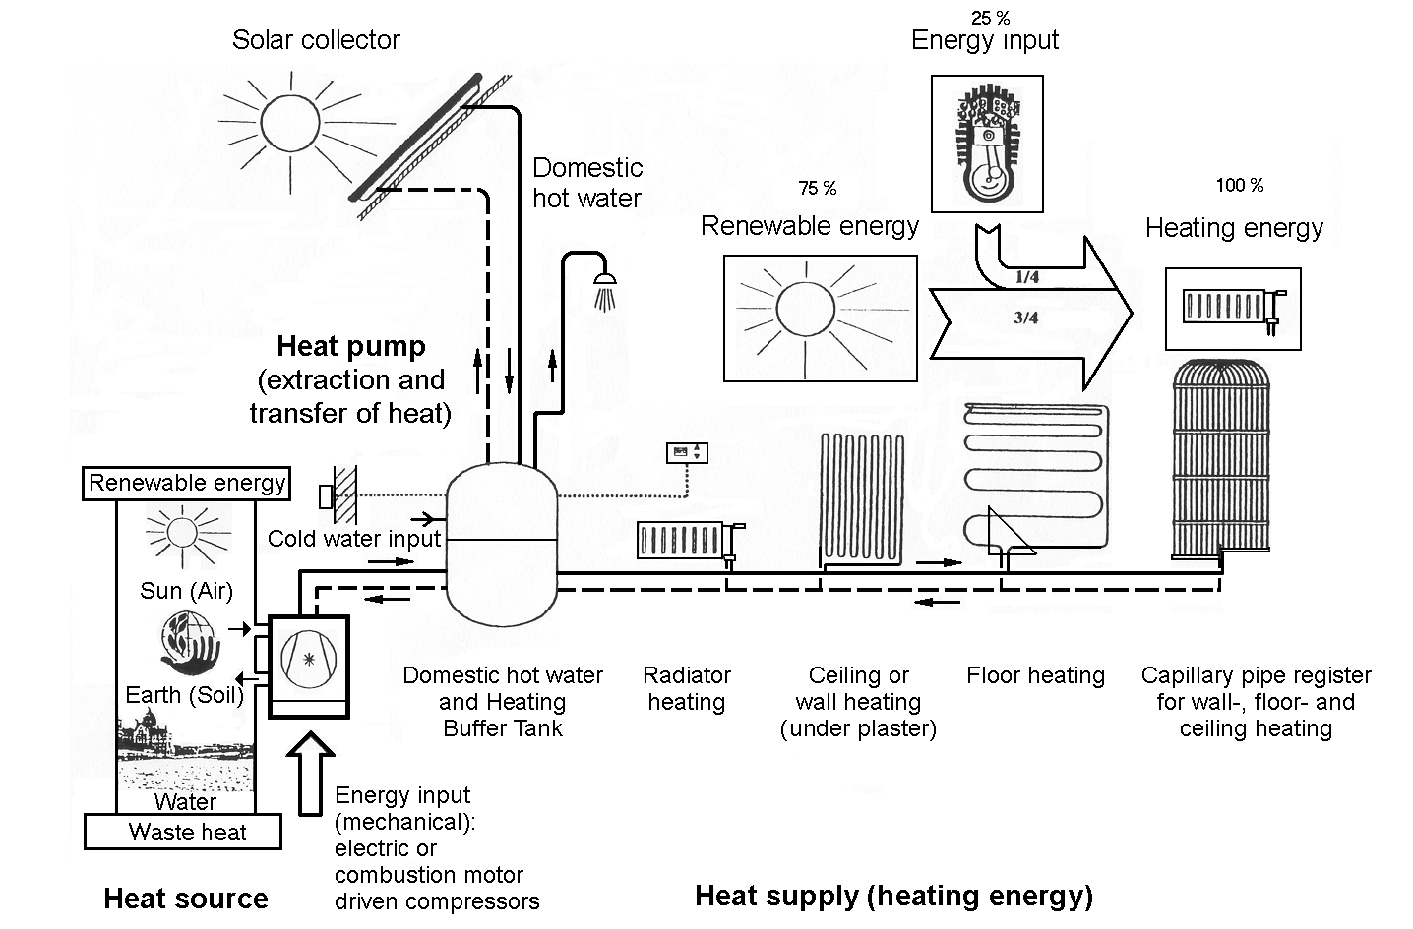

Fig. 1: Principle diagram of a heat pump system with solar collectors (and Sankey-energy)
[Source: EVN Energie - Versorgung Niederösterreich Aktiengesellschaft 1994. p. 5 (Energiflußschema)]

Heating with electrical energy is known for everybody, however because of its high costs generally it can not be considered as energy effective method in Hungary. On the other hand heating with heat pump uses up only a fraction of the electric energy consumed by a pure electric heating to “pump” the heat from the external environment (air, water or soil) to an adequate temperature. Characteristic for a heat pump: With the help of renewable energies it multiplies the electric energy consumed for its operation and function with a factor of 3 - 6 today. A benefit of heat pumps is, that they can be utilised for heating and cooling of buildings and also for ventilating and for producing hot water. Nowadays they are the most effective mechanical means to save energy and to reduce carbon dioxide emission. Tamás Jászai, professor of the Technical University of Budapest used to say at one time: “People do not need kilowatt-hours, wood, coal, oil or gas, but heating, cooling and hygiene!”⁵
By utilising renewable and waste energies (e.g. excavating the heat content of used air, spill water and outlet water) heat pumps promote the more economic utilisation of fossil fuels (coal, mineral oil, natural gas), thus significantly reducing operating costs of the energy supply of buildings [2]. In the field of agriculture heat pumps can be utilised e.g. for drying, tempering, heating and cooling of green houses or for covering the heat demand of animal husbandry. ⁶
In developed industrial countries the first oil crises forced the utilisation of also heat pumps in excess to boilers. As a result they forced the utilisation of low temperature central heating systems, the so called surface heating operating with warm water and being most convenient for the human nature and heat sensation: The heating with radiator of great surface (heat steps of a radiator: 55/45°C, then 40/30°C instead of the former 90/70°C and 75/60°C). Furthermore they promoted the popularisation of floor heating, wall heating and sealing heating and tempering the building structure. In case of these so called human centric, radiating heating methods temperature of the room can be lower (in case of cooling higher) by 2 - 3°C with the same comfort sensation resulting a lower heating or cooling energy consumption by 10 - 15 %.
Heat pumps are proved and effective means especially of geothermal energy - in Hungarian: Soil heat. In several countries heat pumps have preceded the heat production achieved with boilers among free market conditions [3]. The reason is, that beyond heating they can also cool on an energy saving way.
__________________
⁴ A heat pump system is composed by the input energy, the energy supply of the compressor, by the equipment linked with the heat source (evaporating side) and the equipment linked with the useful energy and with the utilisation of the heat (condenser side).
⁵ Now in our everyday life not only cold water but also hot-water cover a natural demand.
⁶ In our days the number of energy supply solutions based on up-to-date heat pumps and heat pump systems is increasing in more and more countries. Since for energy saving these solutions utilise an energy source not increasing carbon dioxide (CO₂) emission, on the contrary their use results in a global reduction of CO₂ emission and of air pollution.
Different energy sources are used for operating the different heat pumps and the traditional heat producing devices. When comparing their from an energetic point of view different factors are to taken into account and the whole chain of energy transfer must be considered from the utilisation of primary energy to the heat flow used up by the consumer as the last phase of the energy flow.
The heat pump is only one element of this system, however determining the whole system! Before this has been realised numerous problems arose. It is not enough to produce, bringing to market, eventually promoted by the state, but one have to think complex, in a system and have to act accordingly. Only this way leads to a situation being optimum for the investors, operators and for the national economy on a long term basis. There is a lot of complex intellectual product requiring multiple kind of expertise in the heat pump systems, but there are few material, weight and in spite of these the price can be significant, because also utilisation value is significant!

3. Evaluation of the traditional solutions of heat production and of heat pump systems of different types

Data related to heating devices in Germany are shown by the column chart of Fig. 2. These data can be accepted in Hungary as well for a comparison of heat producing methods from energetic point of view and for the demonstration of the useful heat flow related to the (primary) energy required for the operation.

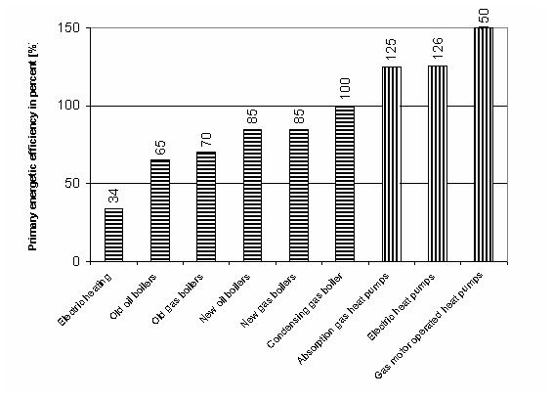
Fig. 2: Primary energetic efficiency of different heat producing methods* [Source: Ruhrgas AG]
(*Primary energy: Collective noun for elemental energy sources being available and can be utilised for energy transform.)

Beyond the energetic benefits of the use of different heat pumps (three columns on the right) necessity of replacing the obsolete heat producing devices can clearly be seen from the column chart as well!⁷ Based on life and property protection not only making the flats more comfortable also heating reconstruction is an important task because of natural gas fuelled devices and of the outdated brick chimneys. Heat pumps are more and more popular for heat production instead of boilers. In Sweden heat pumps are installed in nine of ten new built one-family houses and during reconstruction of building heating heat pumps are installed to a proportion of about two third. The Japanese government foresees the installation of 5.2 million household heat pumps till 2010 and gives significant state support for it as well.⁸ Beyond electric heat pumps they include also gas engine heat pumps and absorption heat pumps working with gas still waiting for popularisation in Hungary with special respect to our gas pipe network being outstanding also in an international comparison [4].
__________________

⁷ This figure does not contain every known solutions (e.g. single heating systems, so called bio-boilers, wood evaporating and pellet fuelled boilers used in Austria as well), only those being typical and frequent.
⁸ Source: The Japan Journal, 2006 Vol. 3 - N°.6

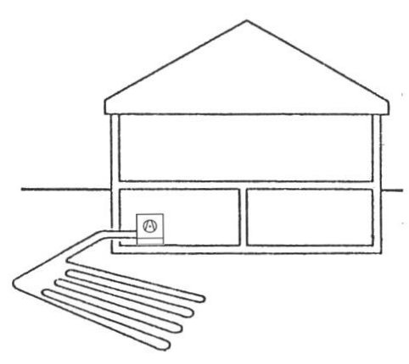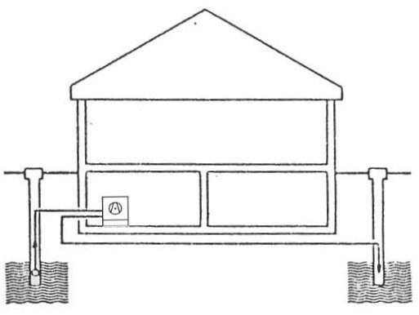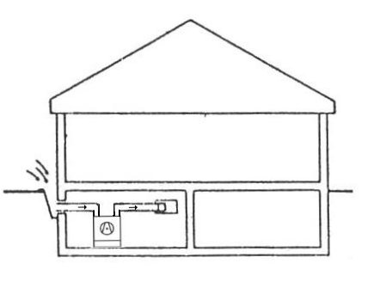

Fig. 3: Brine/water (B/W) Fig. 4: Water/water (W/W) Fig. 5: Air/water (A/W)
Heat pump diagram Heat pump diagram Heat pump diagram

Type of heat pump | B5/W35 | B0/W35 | W10/ W35 | W10/W50
Thermalia 8P | COP = 5,1 | COP = 4,5 | COP = 5,8 | COP = 3,9
Thermalia 15HP | COP = 5,4 | COP = 4,7 | COP = 6,0 | COP = 4,2

Table 1: Measurement data of brine/water and water/water heat pumps in case of different inlet temperatures on the primary side and outlet temperatures on the secondary side [Source: WPZ Wärmepumpen-Testzentrum]

Type of heat pump | A2/W35 | A-7/W35 | A2/W50 | A-7/W50
Genius 08 | COP = 3,5 | COP = 2,6 | COP = 2,5 | COP = 1,9
Genius 12 | COP = 3,5 | COP = 3,0 | COP = 2,5 | COP = 2,2

Table 2: Measurement data of air/water heat pumps in case of different inlet temperatures on the primary side and outlet temperatures on the secondary side [Source: WPZ Wärmepumpen-Testzentrum]

Analysing Fig. 2 main characteristics of heat pumps can be seen: During their operation they are able to produce heat by multiplying the input energy (e.g. electric). Standard designation of this is the COP value as an acronym of the English term “Coefficient of Performance”). Tables 1 and 2 list the results of a standard test of several so called compressor electric heat pump (for interpretation see Fig. 3 - 5).⁹

4. Reduction of air pollution, limitation of chimney construction

People living in settlements experience the change in air quality in the first line from the deterioration of the environment. Statistical data show, that more then the half of the inhabitants of our country live in areas with polluted air.¹⁰
In developed industrial countries quality of external air have been improved in the towns as well due to the utilisation of up-to-date heating methods. It have to be acknowledged, that as a joint impact of development of environment protection and of technology the number of smoking chimneys has not to be increased, but reduced. A limitation of chimney construction is to be introduced in case of new buildings. One chimney for one building scheme, i.e. central heating has to be promoted. Limitation for the so called “circulation boilers” and “combined circulation boilers”, i.e. for single heating installed in new built blocks of flats is suggested. From the point of view of energy efficiency and environment protection central heating supplying larger blocks is the favourable solution. It means an energy saving of 20 - 25 % in spite of the fact, that it causes more heated rooms. Such solutions are the heating (cooling) for the supply of buildings with several stories, block buildings and building groups. Settlement of the heating (cooling) accounts can take place for every flat. Thus installing single heating in every flat is not necessary in case of blocks of flats. Central heating/cooling or district heating/cooling can be arranged for every building or for several buildings resulting better efficiency and lower losses. Thus there is no need for the outlets of combustion products from many boilers and for environment polluting, expensive chimneys. There is no need for space consuming and cost increasing fuel magazines, gas pipes, they are safe, there is no threat of carbon monoxide poisoning, of explosion with special respect to the increasing number of such accidents, furthermore they are hygienic, etc. Short and long term benefits for investors, operators and the national economy have to be taken into account as well.
__________________

⁹ Letters B, W and A in the tables mean heat media (B: brine; W: water; A: air) and the values after them are for measurement results at the given temperature in °C.
¹⁰ The most severe situation rules in towns with a low level of vegetation.

5. Decentralised energy production

Need for cooling in summer increases significantly in Hungary as well. In summer the cooling energy need arise mainly in case of office buildings, service buildings and those of light construction and in attic rooms. Therefore a better focusing onto the local energy affairs, promoting the decentralisation of energy system by most possible complex solutions are important tasks. In case of investments combined heat and power production (e.g. by gas engines or gas turbines) is a mean of efficient energy production.¹¹ Essence of it is, that the same process produces electric and thermal energy in the same time. This combination results generally in an energy source saving of about 50 % and without network losses.¹² In case of decentralised energy production generation of electric energy takes place near to its consumers. If cooling energy is needed as well, then tri-generation (joint production of electric, thermal and cooling energy) can be applied.
In our days comprehensive restructuring takes place in outdated downtowns of several cities and smaller settlements. In excess to decentralised energy production we have to prepare ourselves for learning, popularising and using so called passive architectural means (e.g. green roofs, green facades, water surfaces).¹³ Similar to the combined energy production of power plants heat pumps produce heat with energy saving as well. There are several possibilities of energy saving: End energy reduction (e.g. by heat insulation), efficiency increase (e.g. by up-to-date boilers), combined energy production, heat production with heat pumps and utilisation of renewable energies. Means (e.g. bio-boilers, solar collectors, solar cells) for the utilisation of renewable energies (e.g. solar irradiation, soil heat, bio-mass, bio-gas), thus heat pump systems can be decentralised and autonomous small regions, autonomous buildings can be arranged. Alternative power plants combined with heat pumps (e.g. bio-solar thermal power plants) can play a main role in enhancing local supply security. As a result of their operational impact employment opportunity of those living in the settlement, in the small region (e.g. by the jobs linked with energy plantations, bio-gas production) and health of the population improves if air pollution decreases. According to recent expectations combined energy production with Stirling engines (power range: 1 - 100 kW) will be introduced in homes, in social, medical, sport and cultural institutions soon, within a couple of years.

6. Popularisation of heat pump systems

According to statistical data three fourth of Hungarian flats have natural gas based heating. In Hungary the owner is the user of the flat at the same time, except e.g. tenement flats (6 - 8 %). Interest of flat users for the enhancement of thermal comfort can be arisen easier, i.e. life and environment protection and energetic points of view can be realised on a long term basis.
In the EC 15 and in Hungary as well 40 % of the final energy use is taken by room heating. According to calculations based on statistical data average consume of room heating in Hungary: 0.90 GJ/m².year; in the EC 15: 0,53 GJ/m².year and one third of public electric energy consumption belongs to warm water boilers! Efficiency of electric energy generation in Hungary: 34 %, in the EC: 40 %. Average energy consumption of a flat in Hungary is 60 GJ/year the 70 % of which is used for flat heating and 11 % for water heating [5]. It is important to stress, that 60 - 70 % of the consumed energy in developed countries covers heat production as well [5]. It is unfortunate, that importance of thermal energy consumption, namely of heating and cooling has been “hushed up” for a long time by the responsible persons, however this is listed in every relevant EC material with emphasis: E.g. TNM decree 7/2006. (V.24.) on determining the energetic characteristic values of buildings being the first legislative rule of the introduction of the above mentioned EC directive.
It poses a problem, that in case of new built residential and office buildings the investor is in general not the operator and thus is not interested in endeavouring optimum energy consumption of the building on a long term basis. Investor could sell the flats and offices on a market price at a m² basis. This will be changed in the future as a result of EC directives.
__________________

¹¹ It must be stressed, that increase of combined heat and power (CHP) is an expectation by the EC. The relevant directive promotes also the so called micro gas turbines (< 50 kW).
¹² Means about 10 % saving.
¹³ Known essence of passive attitude: Let the building be saved from external impacts and mechanical means are used for heating and cooling only in utmost cases.

Essence of the Heller Programme is, that on a long term basis natural gas fuelled boilers and gas and electricity fuelled water heating devices and energy wasting air conditioners have to be replaced by heat pumps of different designs and operating modes meeting public requirements and mainly utilising soil heat (geothermal energy). These systems have to be produced in Hungary, dimensioned, installed, maintained by Hungarian manpower in the first line for Hungary and for Middle-Eastern Europe. Further development of them should take place in Hungary as well in the future. Not the product but the service and realisation of the technology have to be supported to enable a marketing also in other e.g. in the neighbouring countries.¹⁴
Heat pump systems belong to the technology of the future and now there is an urgent need to change to future technologies to improve the efficiency of energy production based on fossil fuels. Efficiency increase is a mean for energy saving in turn. This new programme proposal should be launched on a government level. This programme would create jobs with a gradually increasing number, saves significant energy cost, reduces the sensitivity against gas prices and decreases the problems in the filed of industry, service, energy sector and environment protection. Therefore it is very important, that investments and energy policy of the next period include also the Heller László Porgramme.¹⁵ This programme would cover education, public acceptance, production, installation and service. Essence of the programme, that - unfortunately failing native manufacturers - heat pump manufacturers with cutting edge technology should be settled in Hungary on a free market basis gradually involving Hungarian manpower in subcontracting tasks, installation, service, research and development. Thus with the spread of heat pumps the number of flats and public buildings with central and district heating would increase. It must be respected, that natural gas is a more valuable energy source with limited reserves and is a raw material of chemistry, thus utilising it for electricity production in excess to heating as a general practice (combined heat and power) and/or for cooling (trigeneration) and for production of environment friendly energy sources in the future means a more effective utilisation of it.
At the beginning stage of technical development the realisation of new technologies require higher investment cost at the price conditions of today than the traditional procedures. On the other hand because of long life span and lower operation costs the higher investment costs - in case of professional design, installation and operation - will refund several times during the operation of the equipment! Heat pump technology as a mean for rational utilisation of renewable energy sources could enable a breakthrough in the development of our country. For energy saving of about 40 % it uses an energy source without carbon dioxide (CO₂) emission, the use of heat pumps results in a significant decrease in CO₂ emission air pollution on a global level. Heat pump technology can in Hungary be as successful as the natural gas programme, can compete with the later and finally can take over the leading role as a more favourable solution in the field of energetics. Thus with the reduction of air pollution health and life quality of the population can improve.
The “László Heller Scheme as a Job Creating Initiative” - with its short title ”Heller Programme” - foresees the realisation of these goals. I would be happy if Hungary could be the flag-bearer of the popularisation of heat pump technology in Middle Europe.¹⁶

References

[1] Ferenc Komlós: Heating and Cooling with Heat Pumps, the Heller Programme - Igphx Cooling and Air Conditioning technology, Vol. XIII, 2007/1, pp. 26-28
[2] Alajos Stróbl: Energy Saving Environment Protection - OMIKK, Environment Protection Booklets, 1999/8.
[3] Judit Mádl née Szőnyi: Geothermal Energy Reserves, Research, Utilisation - Grafon Publiching, Nagykovácsi, 2006
[4] Dr.-Ing. Lajos Joós: Gas Consumption by the Household and by Small Consumers - Frohner Bt., Pécs, 2005.
[5] György Vajda: Energy Utilisation - Publishing House of the Hungarian Academy of Sciences, Budapest, 2004.

__________________

¹⁴ Some endeavours can be experienced in harmony with the Heller Programme, e.g. a heat pump mounting manufacture, giving notice for a patent at the Patent Office based on novelty research (reference number: U0600213).
¹⁵ Since November 2005 it has become known in workshops and conferences (on architecture, energetics, agriculture, sanitary engineering and environment protection) through publications and its application has been launched.
¹⁶ Timeliness of the proposal and bringing it into decision making status is grounded by the introduction of the mentioned directive of EC on building energetics.

