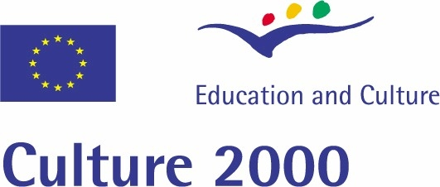
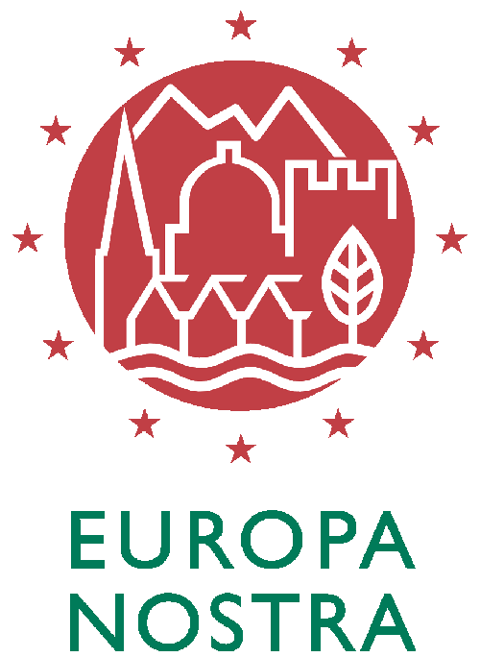

PRESS RELEASE strictly embargoed until Thursday 26 April 2007

LAUREATES OF THE “EUROPEAN UNION PRIZE FOR
CULTURAL HERITAGE / EUROPA NOSTRA AWARDS” ANNOUNCED

The Hague, 26 April 2007: The European Commission and Europa Nostra, the pan-European Federation for Cultural Heritage, today announced the laureates of the annual European Union Prize for Cultural Heritage / Europa Nostra Awards.

The Awards will be presented to the representatives of the awarded achievements at the annual European Heritage Awards Ceremony, which will take place on 8 June 2007 in the Stockholm City Hall in Sweden. Europa Nostra's President, HRH the Prince Consort of Denmark, Ján Figel', Member of the European Commission responsible for Education, Training, Culture and Youth, and HRH Princess Madeleine, Patron of Europa Nostra Sweden, will participate in this major event. The ceremony will be honoured by the presence of Their Majesties the King and Queen of Sweden.

These European Heritage Awards were jointly launched in 2002 by Europa Nostra and the European Commission, in the framework of the Commission’s Culture 2000 programme, to recognise best practices in heritage conservation on a European level. The aims of this Awards Scheme are three-fold: to promote high standards in conservation practice, to stimulate trans-boundary exchanges of knowledge and skills, and to encourage further exemplary initiatives in the field of cultural heritage.

A total of 158 excellent applications and nominations from 32 countries were received in various categories and assessed in situ by independent experts. The most outstanding of these were selected by the Heritage Awards Jury in a series of meetings which took place over recent months. The range of exemplary initiatives submitted illustrated the many facets of Europe's rich cultural heritage, ranging from the restoration of buildings and sites, their adaptation to new uses, new buildings in conservation areas, urban and rural landscape rehabilitation, to archaeological sites, care for collections, research and dedicated service to heritage conservation.

Five top Prizes, which each include a monetary award of €10,000, will be presented in the following categories:

Conservation of Architectural Heritage: to the Sarica Church in Cappadocia (Turkey). Having suffered from severe surface erosion due to rainwater infiltration, cracks and flaking, this remarkable example of a rock-carved Byzantine church was rescued, restored and made accessible to visitors. The project principally involved the restoration of the wall paintings, the construction of a new drainage system and the replacement of the eroded rock of the facade with a covering of harder local tuff of similar colour.

Conservation of Cultural Landscapes: to Santo Stefano di Sessanio near l'Aquila (Italy). The visionary action of a private investor has permitted the dramatic rescue of a medieval fortified village in the Abruzzi highlands, which had been completely abandoned under the effects of devastating poverty and rural exodus. Through its rehabilitation as an extended hotel, this important ‘minor’ architectural heritage was thoroughly restored and the local crafts and traditions were revived. The social and economic benefits of the revitalisation of the project have radiated throughout the region.

Conservation of Works of Art:: to the Farbdiaarchiv zur Wand- und Deckenmalerei (Germany). An ambitious project was successfully undertaken by the Zentral Institut für Kunstgeschichte München and the Bildarchiv Foto Marburg to develop a digital database to preserve the Colour Slide Archive of a large photo campaign that took place in 1943-1945 to document valuable paintings and interior decoration in buildings endangered by Allied air raids. The Archive features circa 40,000 images from approximately 480 buildings in Austria, the Czech Republic, Germany, Italy, Poland, and Russia, many of which were damaged or destroyed during the last three years of the war. Now accessible over the internet, free of charge, to scholars and to the general public alike, it also serves as an indispensable research tool on which the restoration of damaged buildings can be founded.
…/contd.
Outstanding Studies: to The Atlantic Wall Linear Museum (Italy / Belgium / France). One of the last major defence lines of the 20th century, the Atlantic Wall was built by the German occupying forces in the period 1941-1944, along the coastline of France, the Channel Islands, Belgium, the Netherlands, Germany, Denmark and Norway. A joint project involving cooperation with numerous partner institutions was launched by the Politecnico di Milano (Italy), the Raymond Lemaire Centre for Conservation in Leuven (Belgium), and the Ecole d’Architecture de Versailles (France), to research and raise public awareness on this valuable transnational heritage. It has successfully contributed to the preservation of our collective memory and shared European history through the publication of a catalogue and atlas, a photo campaign, the organisation of a conference and a travelling exhibition, and the creation of a website.

Dedicated Service: to The Mihai Eminescu Trust (Romania / United Kingdom). By rescuing and repairing more than 300 historic buildings and training more than 100 local craftsmen in traditional skills, this non-governmental, non-profit organisation has done more than any other organisation for the preservation of the Saxon heritage of Transylvania, a treasure of unique European value. Since 1989, the Trust has been working to revitalise the social and economic life of the region, by supporting the restoration of architectural heritage and developing income-generating activities such as ecological and cultural tourism, organic agriculture and traditional crafts.

In addition to the five top Prizes, sixteen Medals (2nd Prize) and thirteen Diplomas (3rd Prize) will be awarded to the following achievements:

Austria – Stift Klosterneuburg (Diploma); Croatia – The Croatian Apoxyomenos, Zagreb (Medal); Denmark – “The Site of Illerup Ådal and the European society around 200 AD”, by J. Ilkjær in collaboration with C. Carnap-Bornheim and M. Biborski (Medal); Paradehuset, Gisselfeld Kloster (Diploma); Texaco Service Station 1938, Skovshoved Harbour (Diploma); Finland – The Porthania, University of Helsinki (Medal); Georgia – The Church of the Virgin, Timotesubani (Medal); Germany – Professor Dr. Dr. Ing. E.H. Gottfried Kiesow (Medal); Wall-Paintings of the Ottonian Crypt, Saint Andrew's Church, Fulda (Medal); The Belvedere on Pfingstberg Hill, Potsdam (Diploma); Hungary – Terminal 1, Ferihegy Airport, Budapest (Medal); New York Palace & Café, Budapest (Medal); Italy - The Association of Significant Cemeteries in Europe (A.S.C.E.) (Medal); Norway - Domus Academica, University of Oslo (Diploma); Poland - Archaeological Open-Air Museum, Biskupin (Medal); Slovenia - Pocarjeva Domacija, Mojstrana (Diploma); Spain - Fundación Caja Madrid - Programme for the Conservation of Spain's Historical Heritage (Medal); Pont Trencat, Sant Celoni and Santa Maria de Palautordera (Medal); San Juan de los Reyes, Granada (Diploma); Sweden – Eslöv Civic Hall (Diploma); “New Foundations and Changes of Plan. Swedish Town Planning 1521-1721”, by N. Ahlberg, doctoral thesis at the University of Uppsala (Diploma); Turkey – “Silk Factories in Bursa and the Conservation of Industrial Heritage related to Sericulture”, by Dr Elif Özlem Oral, doctoral thesis at the Istanbul Technical University (Diploma); United Kingdom – “The Palace of Westminster Conservation Plan”, by Donald Insall Associates (Medal); The Reed & Sedge Cutters Rejuvenation Project, The Broads (Medal); The Roundhouse, London (Medal); Mourne Homesteads, County Down, Northern Ireland (Diploma); St Paul's Church, Bristol (Diploma); Brunel's ss Great Britain, Bristol (Diploma); Cyprus / Greece / Liechtenstein / United Kingdom – The A.G. Leventis Foundation (Medal).

For more information on the Awards, please go to www.europanostra.org/awards_2006.html or contact:

Laurie Neale, Communications Officer, Europa Nostra Tel. +31 70 302 4055 co@europanostra.org
Eléonore de Merode, Heritage Awards Co-ordinator, Europa Nostra, Tel +31 70 302 4052 ao@europanostra.org

Europa Nostra, the pan-European Federation for Heritage, is the representative platform of over 230 heritage NGOs active throughout Europe. It is the voice of this vast movement of European civil society active in the field of heritage towards international bodies concerned, in particular the European Union Institutions, the Council of Europe and UNESCO. Europa Nostra is dedicated to putting heritage and its benefits in the mainstream of public consciousness and to making heritage a priority for public policies both at European and national levels. Its specific objectives are to promote, at a European level, high standards of quality in the fields of heritage conservation, architecture, urban and rural planning and to advocate a balanced and sustainable development of urban and rural, built and natural environment.

Europa Nostra supports national and international campaigns for the preservation and rescue of Europe’s heritage at risk. It encourages exemplary initiatives in favour of the conservation and enhancement of cultural heritage by recognising outstanding heritage achievements, in particular through the running of the European Union Prize for Cultural Heritage / Europa Nostra Awards. In early 2006, Europa Nostra was selected as the new Liaison Office for the co-ordination of the "European Heritage Days", a joint action of the Council of Europe and the European Commission.Through its various activities, Europa Nostra seeks to highlight the importance of cultural heritage as a building block of European identity and as a contribution to the strengthening of the sense of European citizenship. www.europanostra.org

